Cairo University  
Faculty of Computers and Information



**CS251**

**Software Engineering II**

BeHealthy

Software Design

2016/2017

Contents

Instructions [To be removed] 3

Team 3

Document Purpose and Audience 3

System Models 3

I. System Decomposition 3

II. Class diagrams 6

Important Algorithm 7

III. Sequence diagrams 8

Class - Sequence Usage Table 9

IV. Physical Entity-Relationship Diagram 10

V. User Interface Design 10

VI. Bonus: State Diagram and OCL 12

Ownership Report 12

Policy Regarding Plagiarism: 12

References 12

Authors 12

# Team

|  |  |  |  |
| --- | --- | --- | --- |
| **ID** | **Name** | **Email** | **Mobile** |
|  | Donia Khaled |  |  |
|  | Hager Sobeah |  |  |
|  | Safwa Salman |  |  |
|  | Mahmoud Samy |  |  |

# Document Purpose and Audience

* **Any document should tell the reader 2 things: What is this document? Who is expected to read it?**
* **Write in simple notes: what this document is.**
* **List the target audience to read this document (e.g. CEO? Project Manager? Customer...?)**

# System Models

## I. System Decomposition

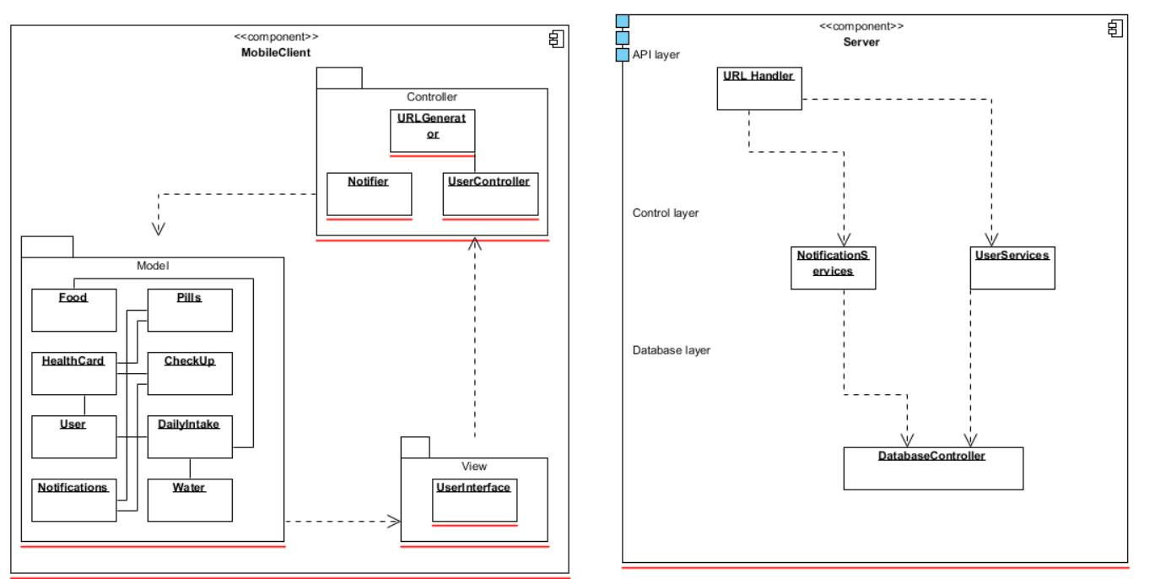

## II. Class diagrams

**1-MobileClient**

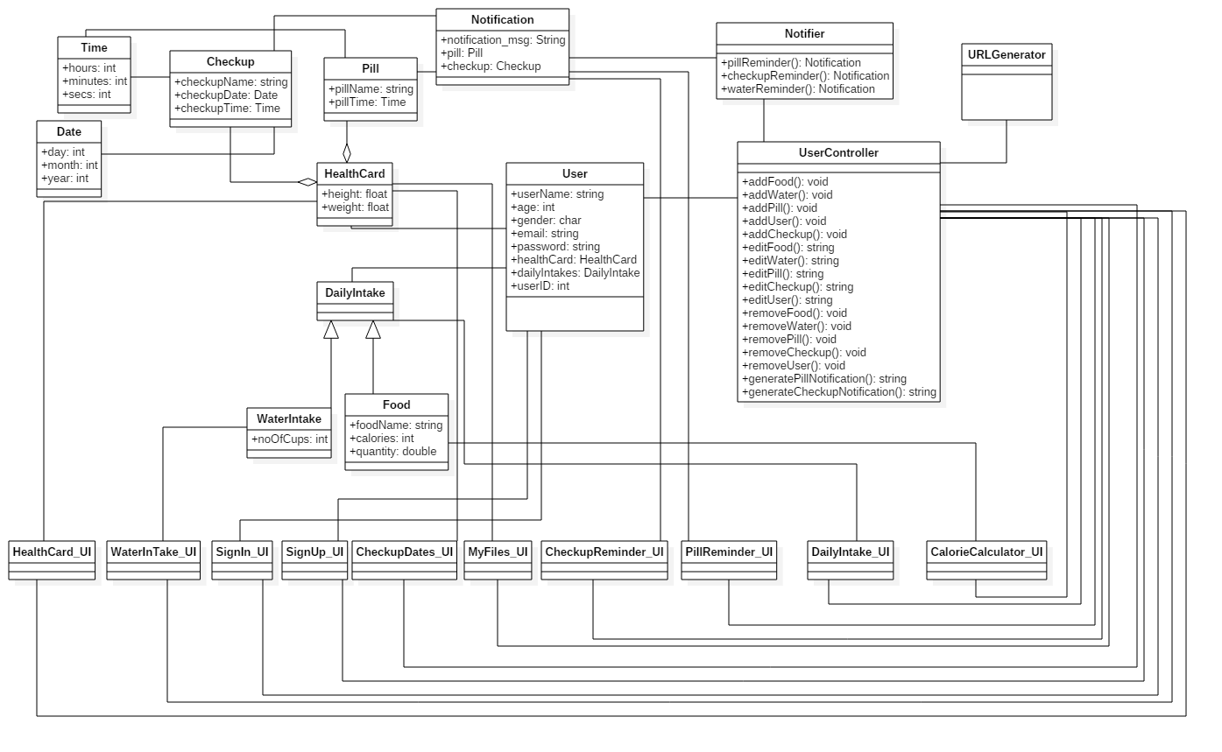

**2-Service:**

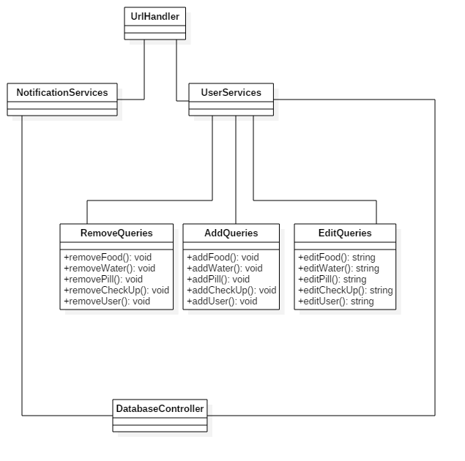

| **Class ID** | **Class Name** | **Subsystem ID** | **Description & Responsibility** |
| --- | --- | --- | --- |
|  |  |  |  |

## III. Sequence diagrams

## Sign up

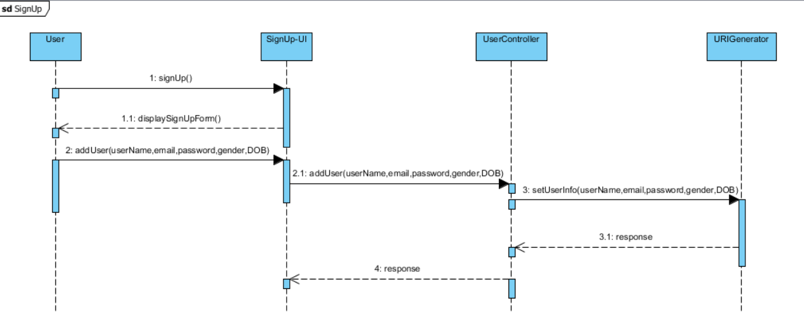

**Sign in**

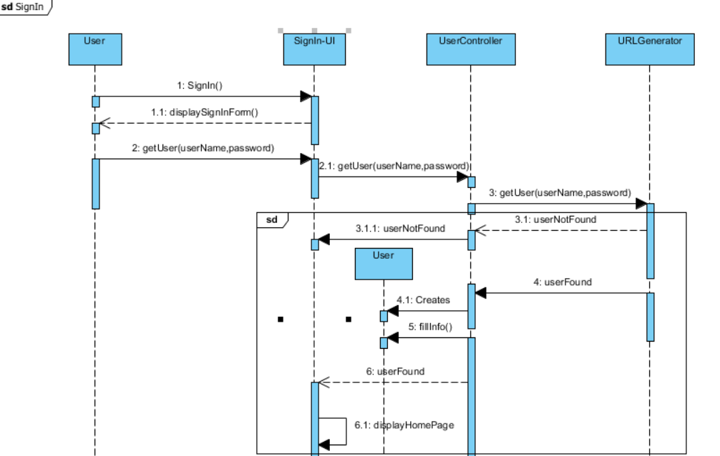

* **Sign out**

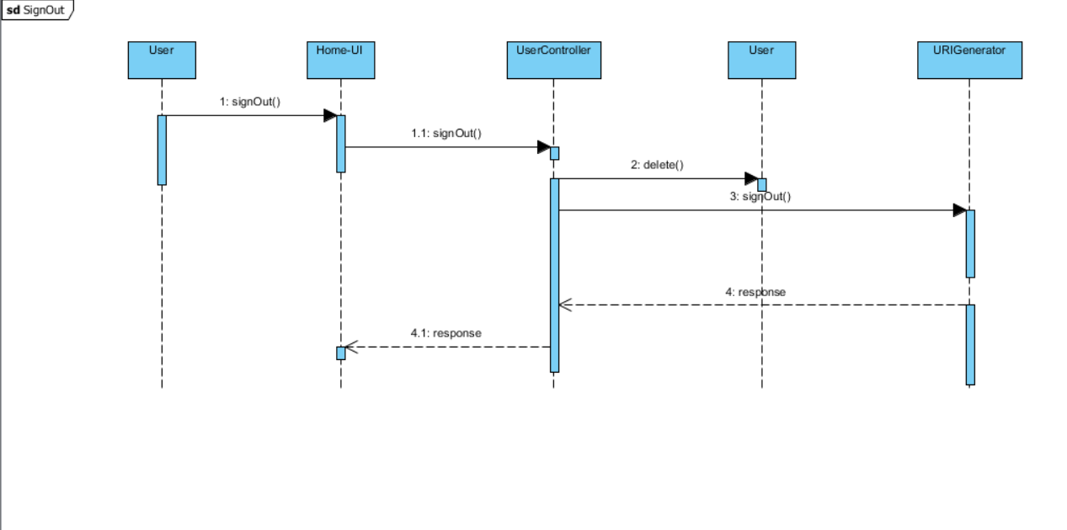

* **Pill reminder**

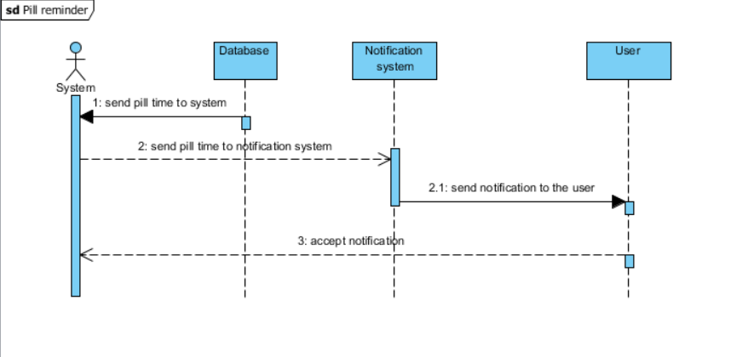

* **Checkup reminder**

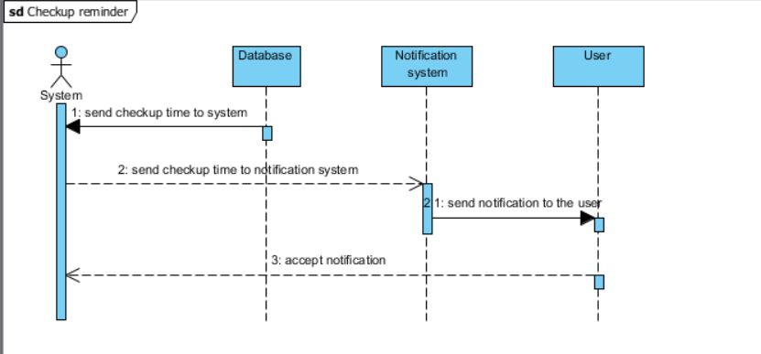

* **Water reminder**

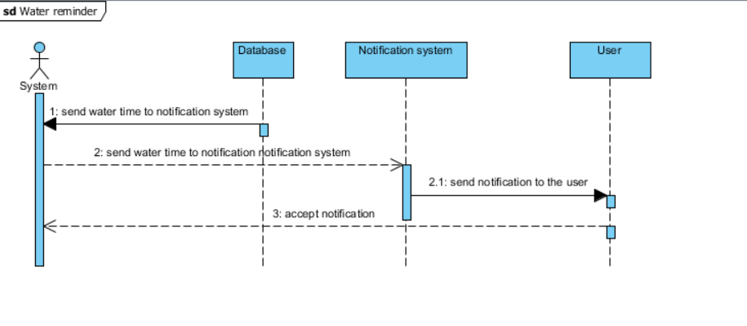

* **Add water**

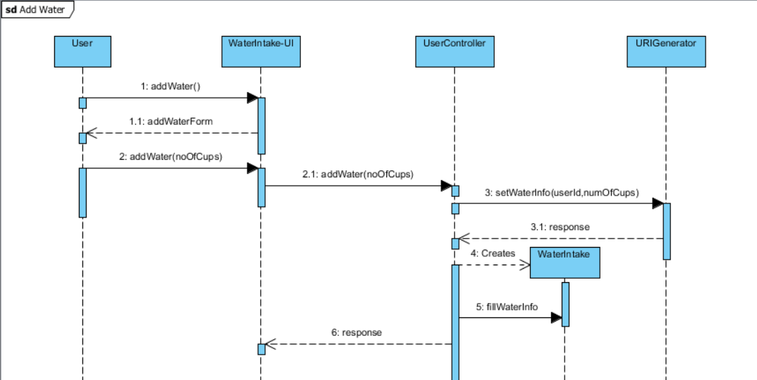

* **Add pill**

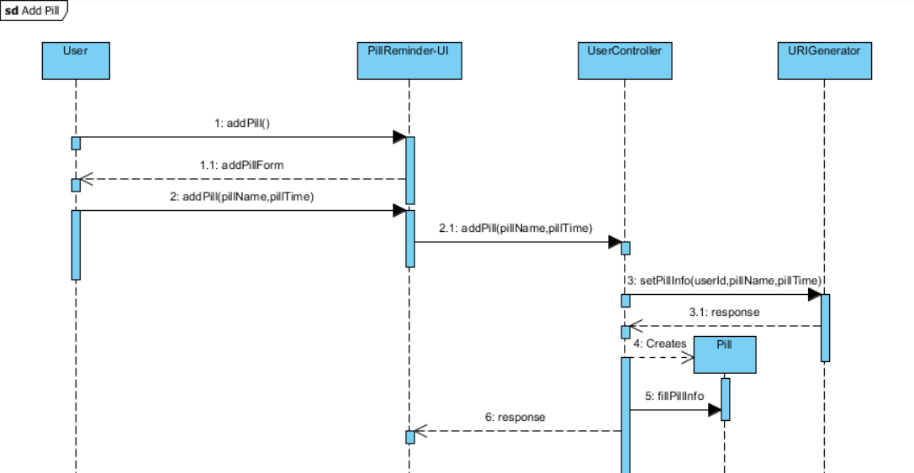

**Calculate calories**

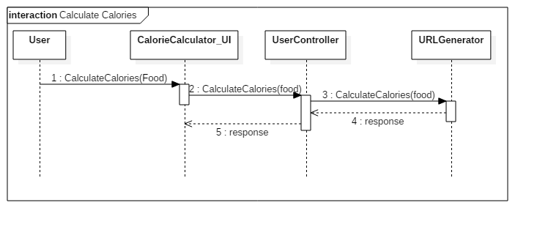

**Add food**

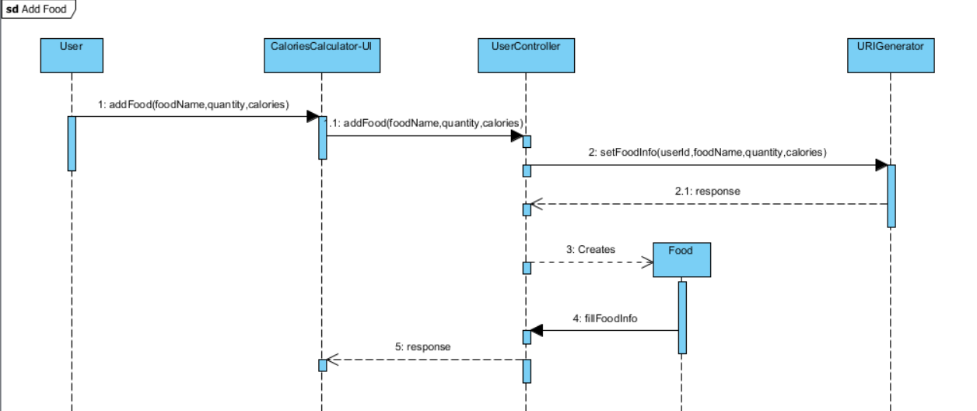

* **Add Health card**

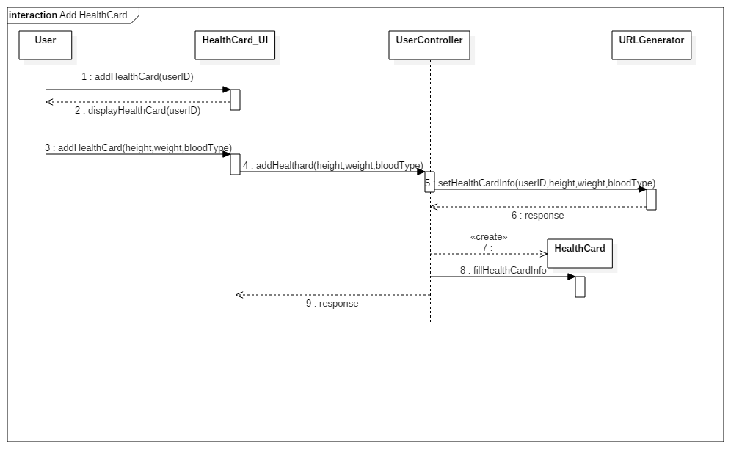

* **Add checkup**

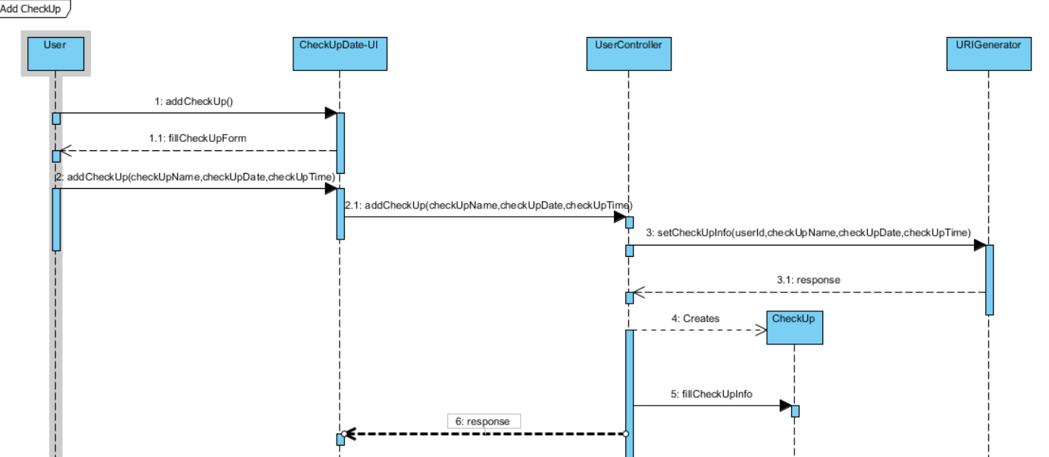

* **Health card**

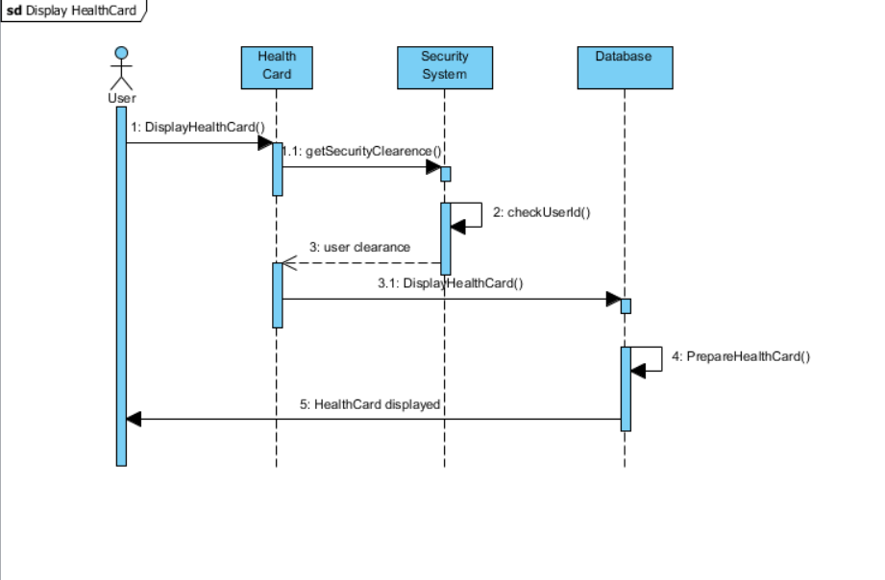

* Class - Sequence Usage Table

| **Class Name** | **Sequence Diagrams** | **Overall used methods** |
| --- | --- | --- |
| E.g. Employee | 1, 3, 5 (means Seq Ids 1, 3, 5 used Employee class) | Save, GetData |
|  |  |  |

## IV. Physical Entity-Relationship Diagram

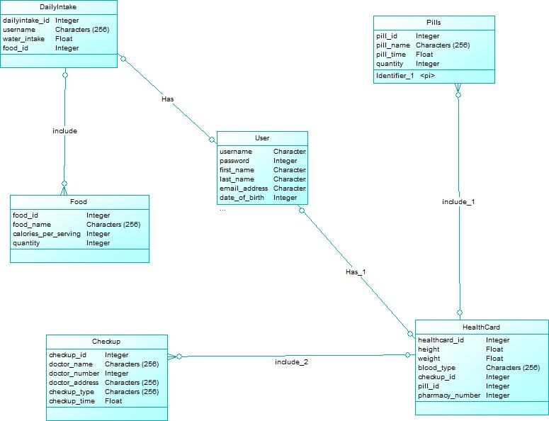

## V. User Interface Design

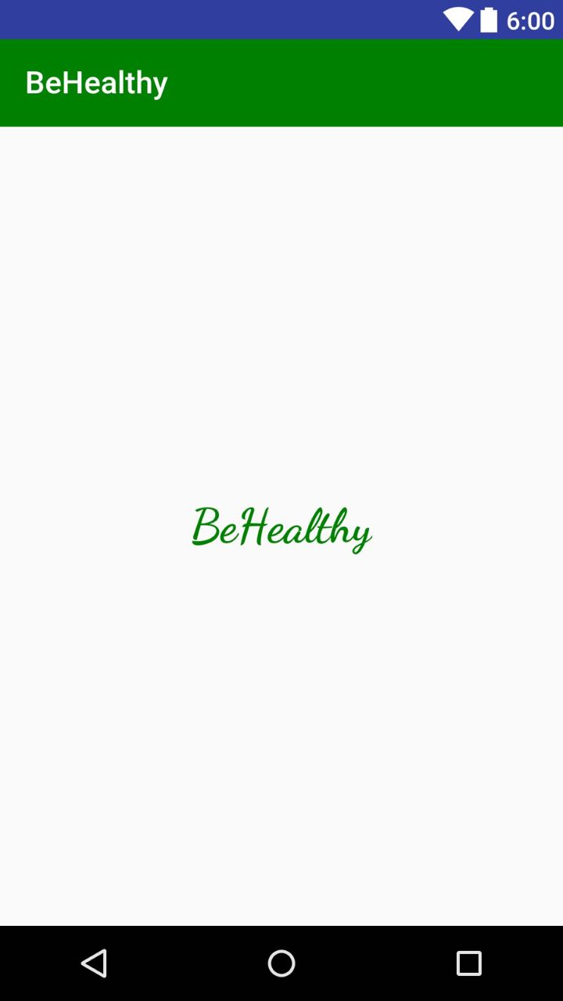

-

* **Screen 2 – Sign In**

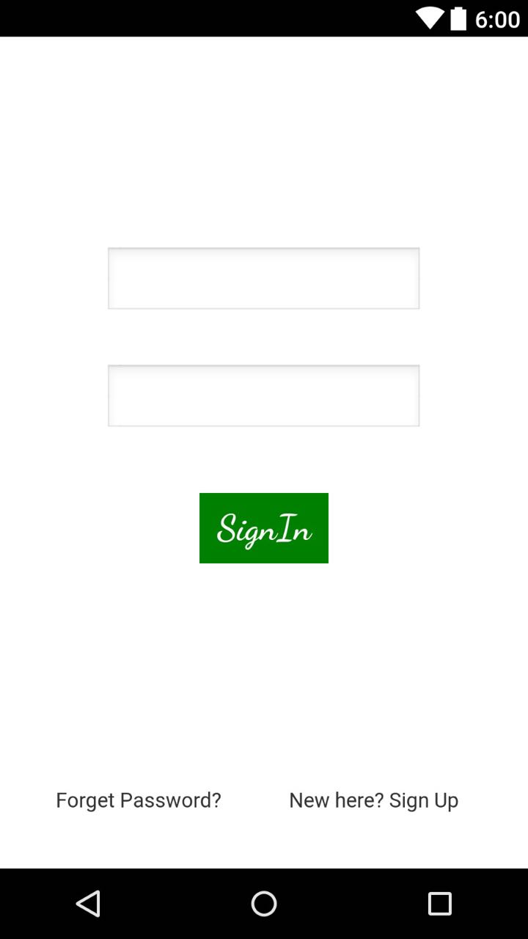

* **Screen3: Sign Up**

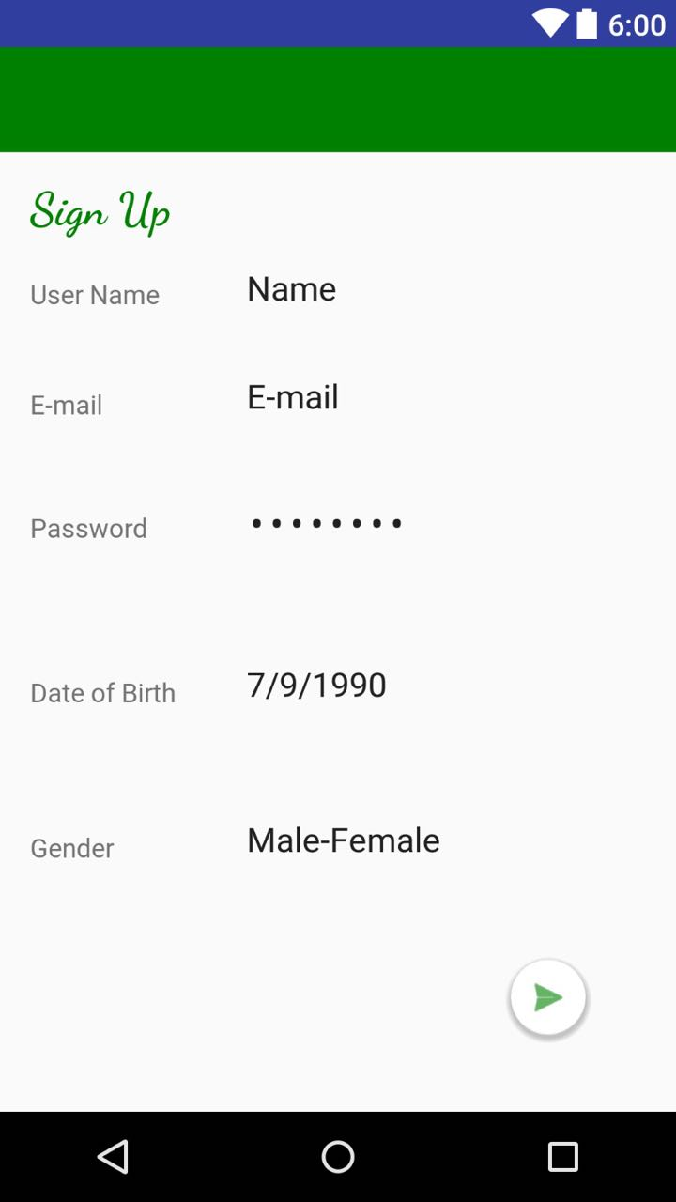

* **Screen 4: Home**

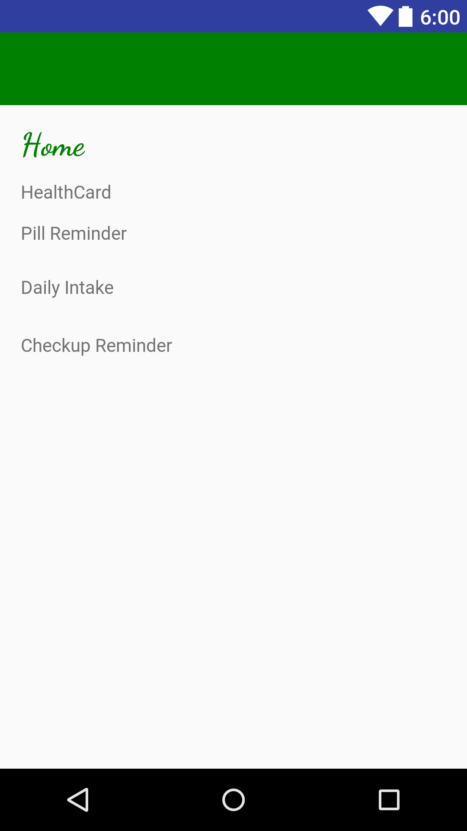

* **Screen5: Health card**

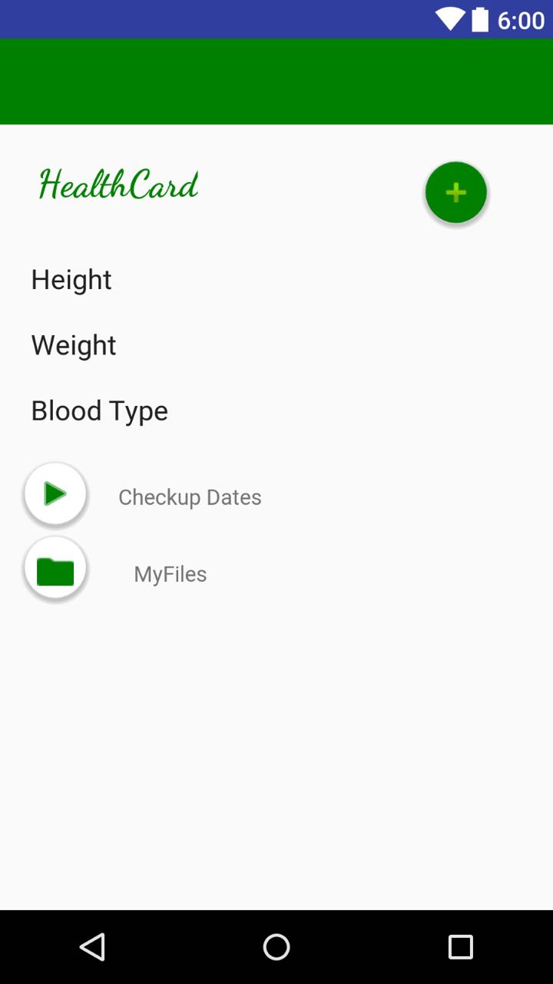

* **Screen6: Pill reminder**

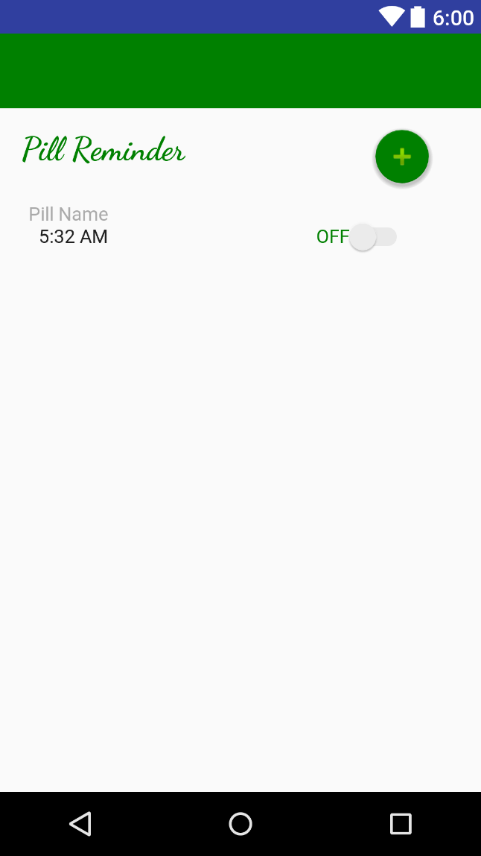

**Screen 7: Daily Intake**

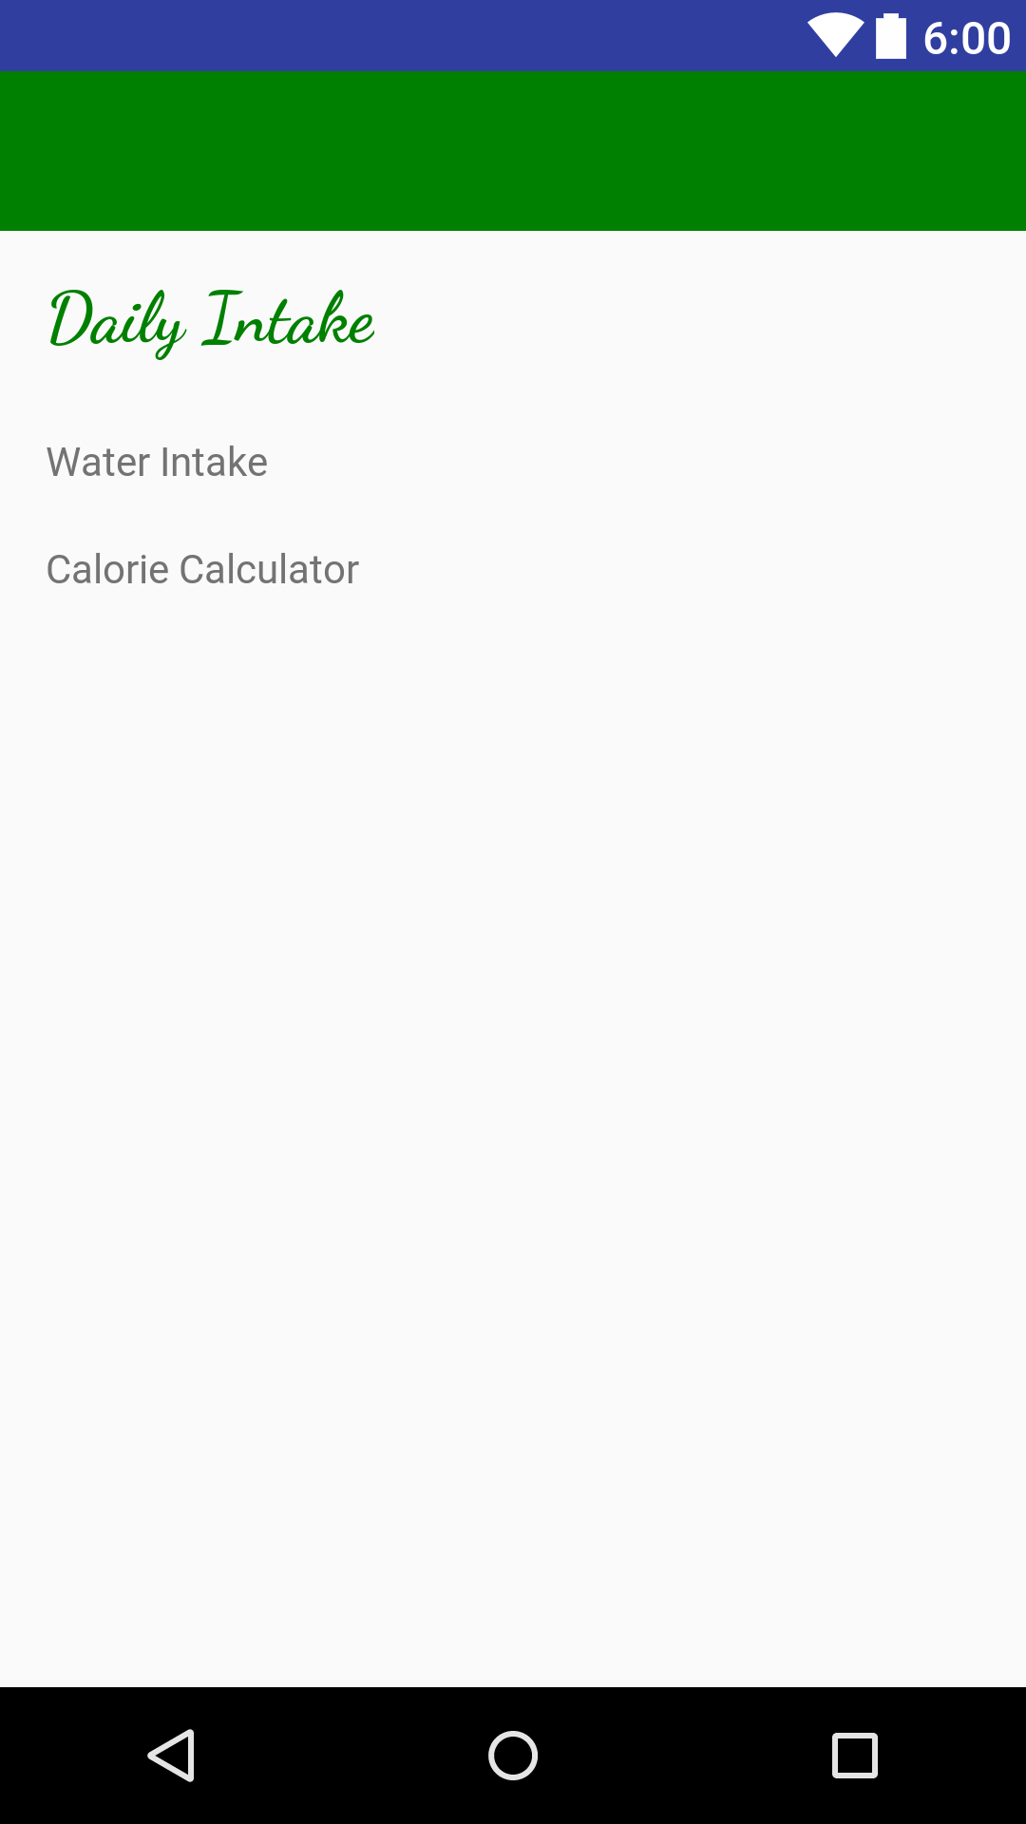

**Screen 8: Checkup Reminder**

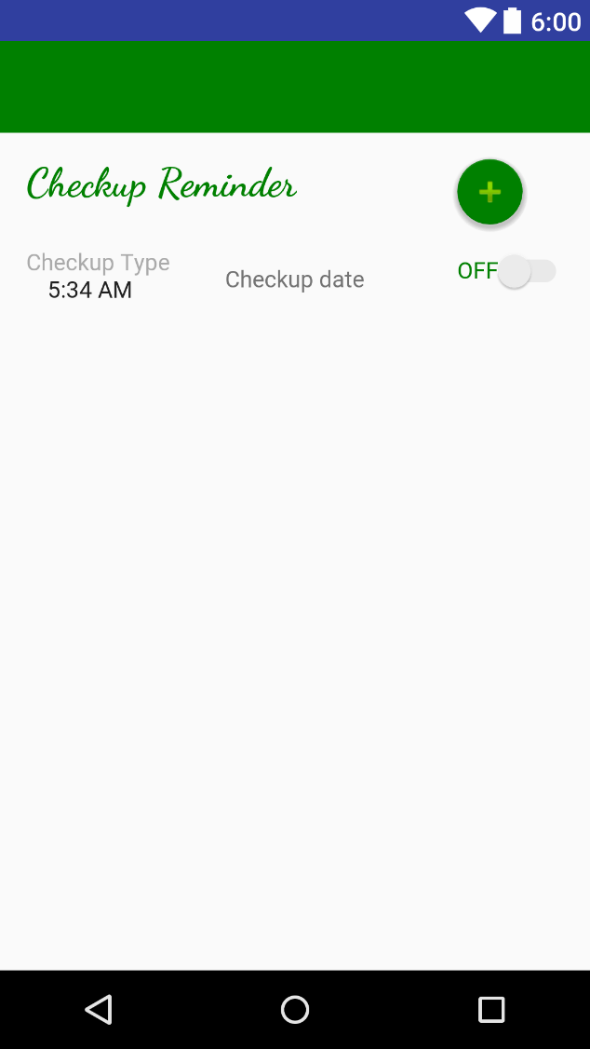

**Screen 9: My Files**

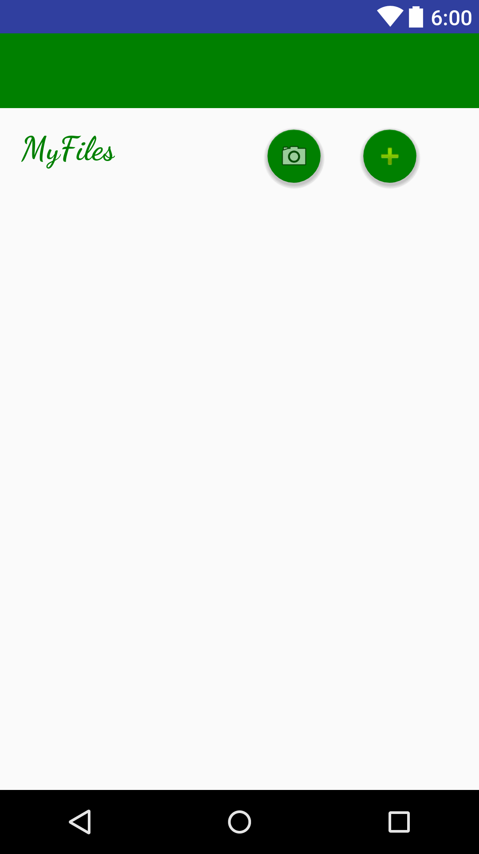

**Screen 10: Checkup Dates**

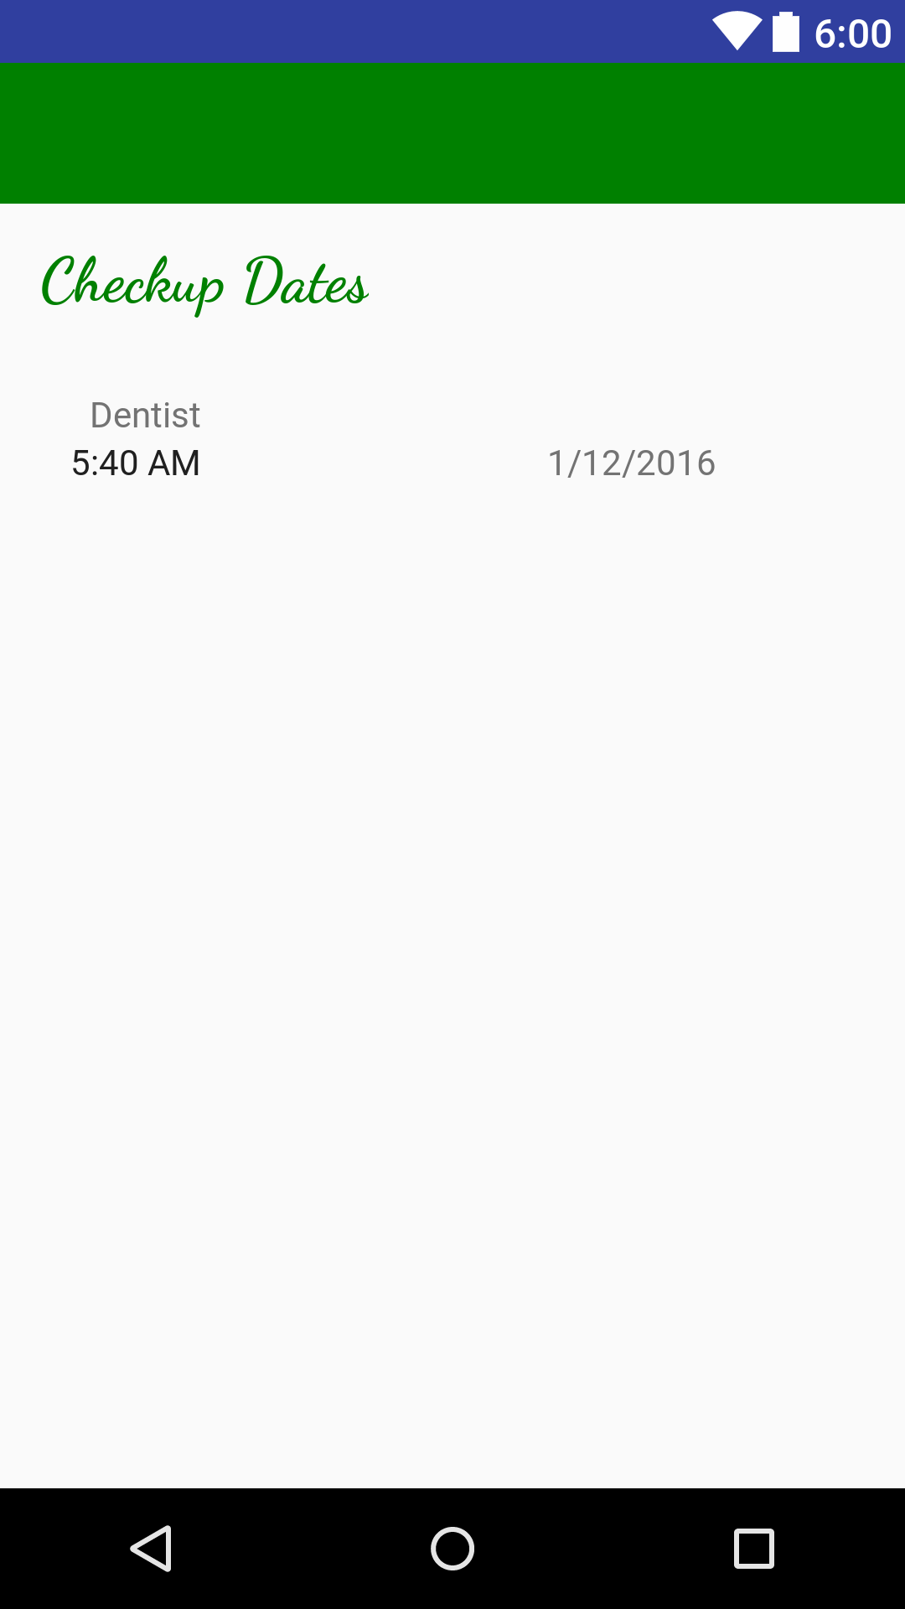

**Screen 11: Water Intake**

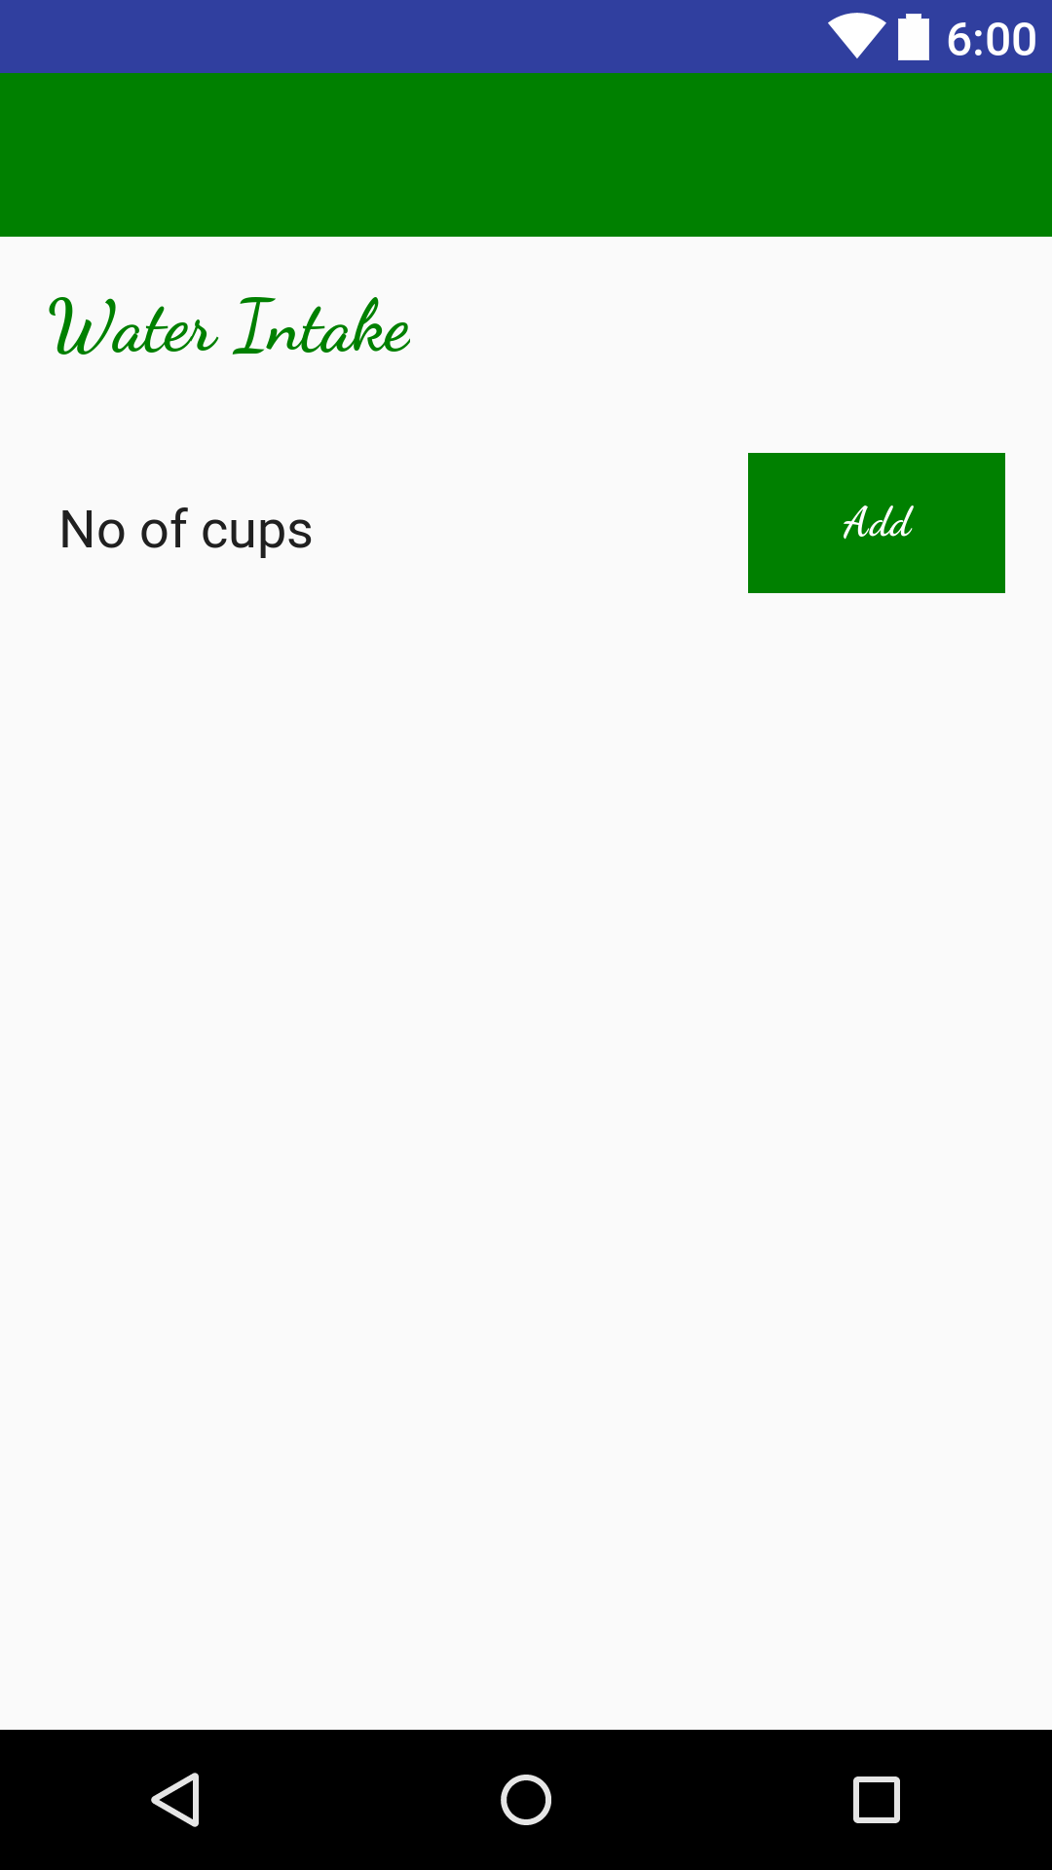

**Screen 12: Calory Calculator**

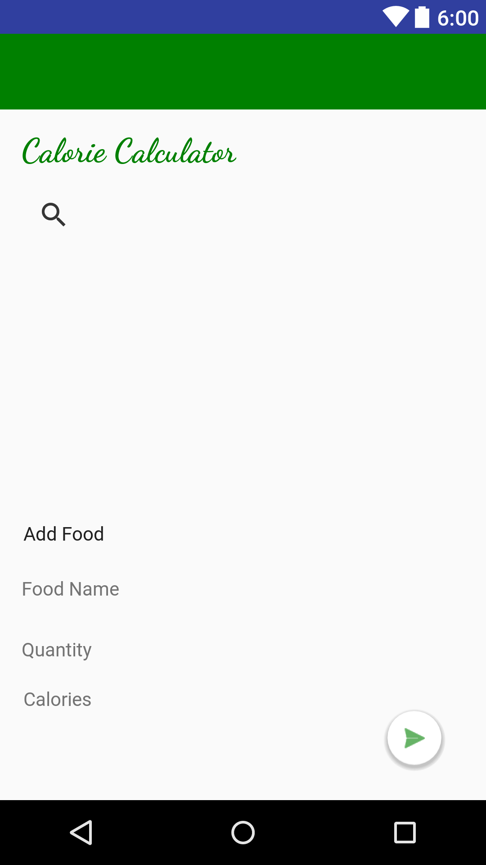

* **Navigation tree: Login Screen**

**|**

* **Navigation tree: Main Screen**

## VI. Bonus: State Diagram and OCL

|  |  |
| --- | --- |
| **Item** | **Owners** |
| Class diagram | *Donia Khaled- Hager Sobeah* |
| System decomposition | *Mahmoud Samy- Safwa Salman* |

# References

* http://www.mhhe.com/engcs/compsci/pressman/graphics/Pressman5sepa/common/cs1/design.pdf

# Authors

* Mostafa Saad and Mohammad El-Ramly